Stakeholders Report for Retail Sales Performance
Company: Konga-Gro Mart
Presented By: Daniel Ifenna
Date: 19th April, 2025.

- Executive Summary
This executive report delivers a comprehensive analysis of the weekly sales across 45+ stores, highlighting key performance drivers including seasonality, markdown effectiveness, and macroeconomic influence on retail performance. Through a combination of exploratory data analysis and dynamic dashboard visualizations, the project aims to equip decision-makers at KongaGro Mart with the intelligence required to optimize operations, tailor marketing efforts, and enhance overall profitability.
- Project objective
The primary objectives of this project are as follows:
- Track weekly sales trends, including holiday-driven spikes
- Identify top- and bottom-performing stores
- Quantify the impact of economic variables (CPI, unemployment, fuel price, temperature)
- Evaluate markdown performance across holiday and non-holiday periods
- Compare holiday versus non-holiday sales contributions
- Recommend strategic initiatives to maximize profitability.

- Key Insights
  - What is the overall trend in sales over time?
Analysis reveals a clear seasonal pattern in sales, characterized by a significant spike during major holiday periods, particularly during Christmas and end-of-year celebrations. These periods reflect increased consumer spending driven by festive shopping behaviors, weather, and promotional campaigns. amongst many other elements However, following the conclusion of Q1, a noticeable and gradual decline in sales is observed. The drop suggests a seasonal downturn, possibly due to reduced purchasing power, seasonal change, and lower promotional activity. It shows the importance of aligning promotion efforts and inventory management with anticipated consumer behavior during peak off-season
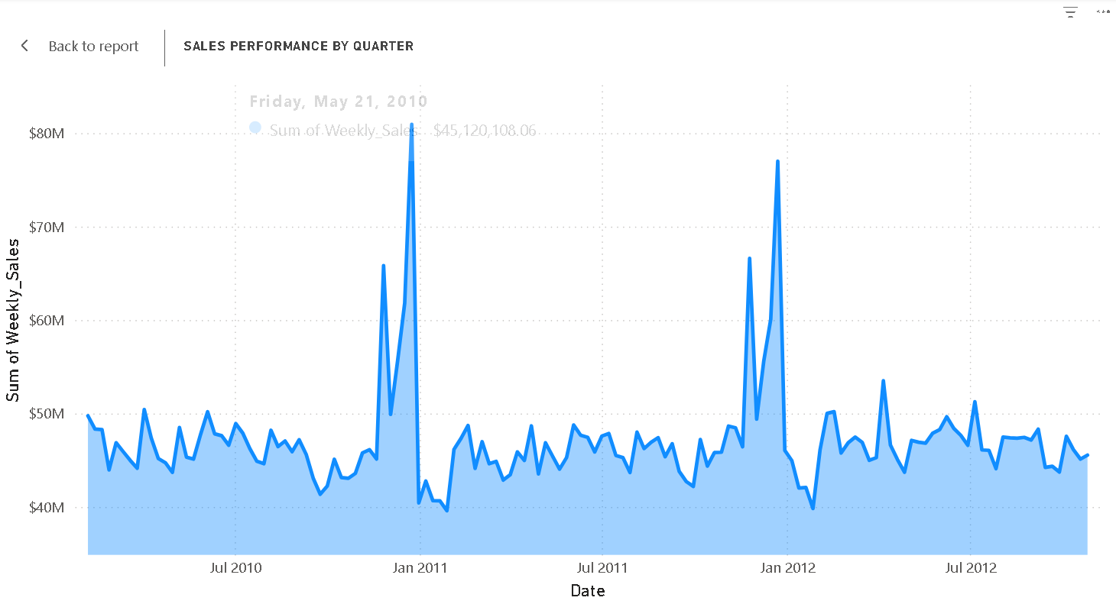

  - Sales Performance by store
The data presented shows that Store 20 has the highest sales so far with a record of $301,397,799 in total sales. However, Store 33 recorded the lowest in sales with a record of $37,160,222 in total sales
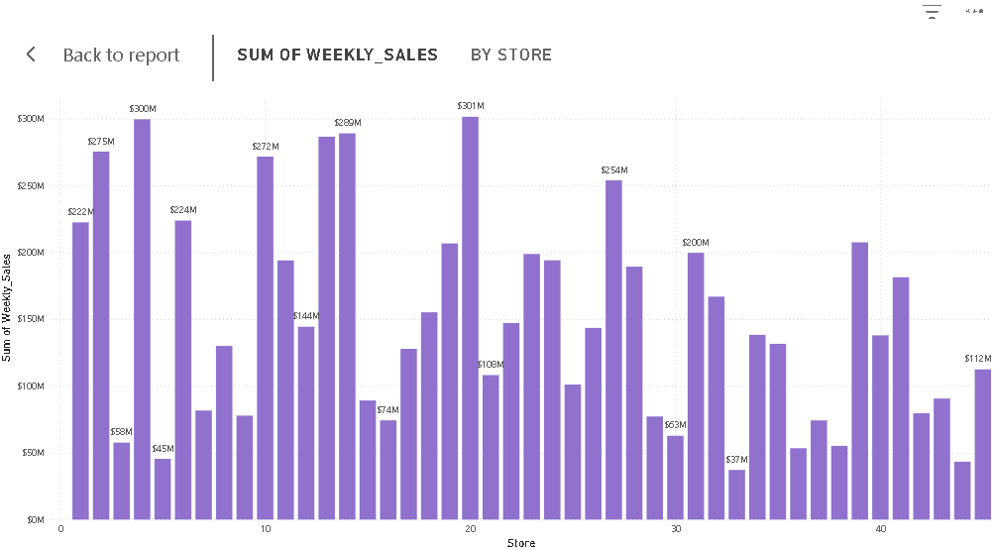
  - Economic Drivers
It was observed that CPI and Unemployment are negatively correlated against weekly sales, also it was of weak significance meaning that the increase in either economic factors leads to little decline in weekly sales.
Also, Fuel price is also negatively correlation but still doesn’t have a strong significance regarding sales. However, Temperature has a modest impact on sales. For example, stores sell more sun glasses during the summer and more winter coats during the winter.
  - How do markdowns affect weekly sales?
Markdowns positively influence weekly sales. First of all, in our analysis, we calculated the mean value for all markdowns based on the holiday period represented as False and the Non-Holiday period represented as True. It was discovered that Markdown 2 and Markdown 3 have the highest mean value during Non-Holiday sales. As Markdown1 and Markdown5 have stronger mean values during the holidays. A linear regression model was built to test the correlation of each markdown to weekly sales, all have a slight positive relationship, as all correlations are less than 0.1

  - Sales Channel Comparison
Holiday weeks: $505.3M — 7.5% of total
Non-Holiday weeks: $6.23B — 92.5% of total
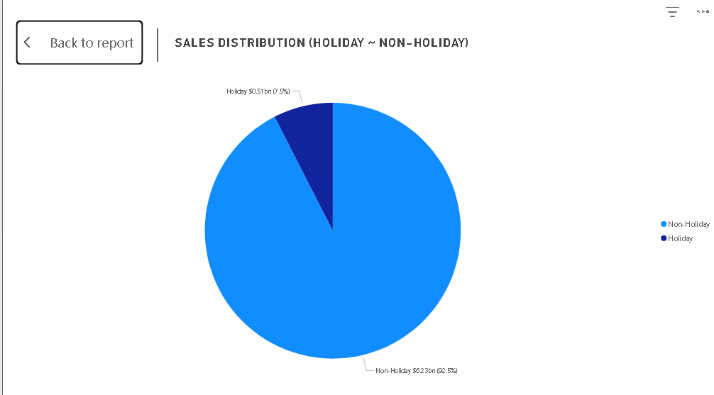
Recommendation
- Markdown 2 and Markdown 3 should be prioritize during off-season, while M1 and M5 at Holiday peaks to optimize ROI.
- External economic variable has limited immediate impact on sales. It is important to note that temperature shows the strongest sales correlation.
- During Holiday period the company should fortify inventory and marketing efforts. Regarding sharp declines of sales after the holiday period the company should consider updating inventory with goods at demand according to its season.
- It is also important for the company to conducting frequent store audits and creating sales target for each store to meet up. Surveys should be conducted regarding work-life balance and staff satisfaction as it may serve as a reason to store performances.

